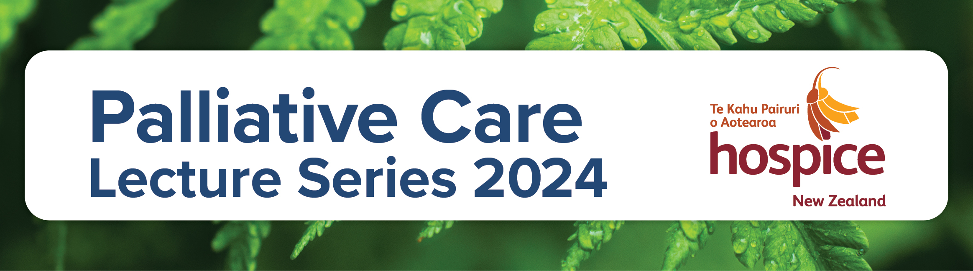

Date/Time  7:30-8:30am | Presentation | Presenters
Lecture 1  1 Feb 2024 | Dying well in old age: Integration of Gerontology and Palliative Care in Residential Aged Care | Dr Michal Boyd  Senior Lecturer, School of Nursing @ University of Auckland & Nurse Practitioner
Lecture 2  7 March 2024 | PCARN (Palliative Care Aotearoa Research Network): Working together to create a positive and inclusive culture of palliative care research in Aotearoa | Cheryl Davies  Co-chair PCARN, Senior Māori Researcher @ Univeristy of Otago
Lecture 3  4 April 2024 | Advanced Care Planning in the pursuit of health equity for Māori | Maarie Hutana  Māori Engagement Manager @ Te Tahu Hauora (Health Quality & Safety Commission)
Lecture 4  2 May 2024 | Social Workers’ stories: Journeys into Palliative Care, Mobilising and Sustaining Practice | Ruth Lee Choi  Professional Teaching Fellow, Faculty of Medical and Health Sciences, University of Auckland. Social Worker, Hospice West Auckland
Lecture 5  6 June 2024 | Palliative Care for Stroke Patients | Professor Brian Le  Director of Palliative Care @ Peter MacCallum Cancer Centre, Victoria, Australia
Lecture 6  4 July 2024 | Public Health/Compassionate Communities approaches to Palliative Care | Professor Allan Kellehear  Chair, University of Northumberland
Lecture 7  1 August 2024 | The role that Paramedics play in Palliative Care | Fraser Watson  Extended Care Paramedic Clinical Lead @ Hato Hone St John
Lecture 8  5 September 2024 | Palliative Care in Renal Failure | Dr Frank Patrick Brennan  Palliative Care Physician @ St George, Sutherland and Calvary Hospitals, Australia
Lecture 9  3 October 2024 | Medicinal Cannabis in Aotearoa | Guest Speaker  TBA
Lecture 10  7 November 2024 | Eye Tissue Donation | Guest Speaker  TBA
Lecture 11  5 December 2024 | Medico – Legal Considerations at the End of Life | Judge Philip Recordon  Retired District Court Judge

